# How to install R and RStudio

## If you are a HZI-Member using your HZI-Computer:

1. Open the Software Center e.g. via clicking “Start” and typing “software center” (the first few letters should be sufficient) and press Enter.

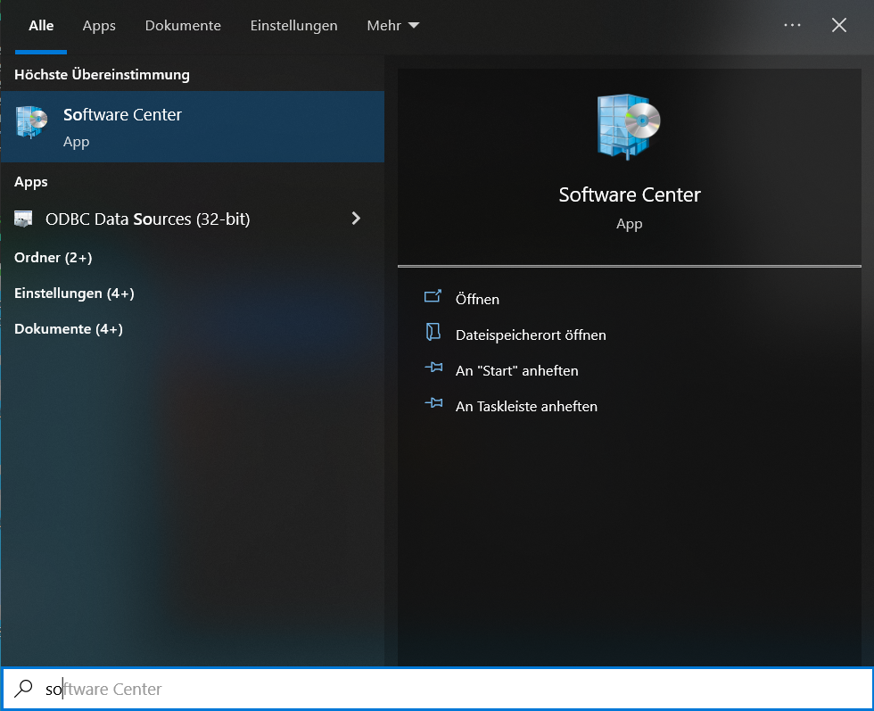

1. If not selected, click on “Applications” in the right hand sided menu.

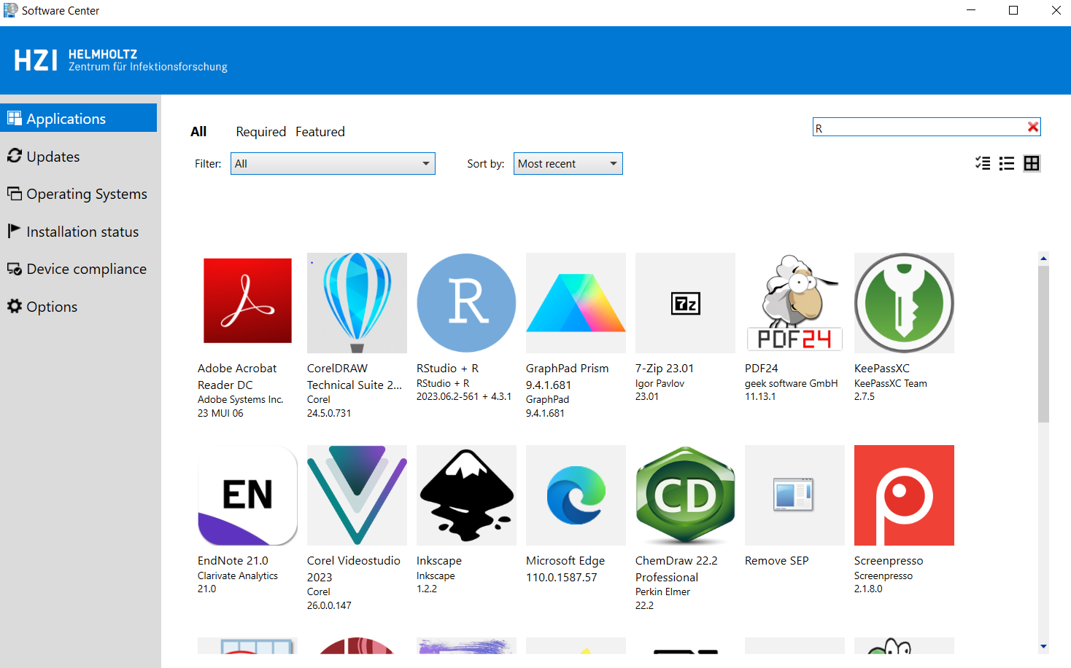

1. Scroll through the applications or use the search bar to find “RStudio + R” and click on the tile.



1. 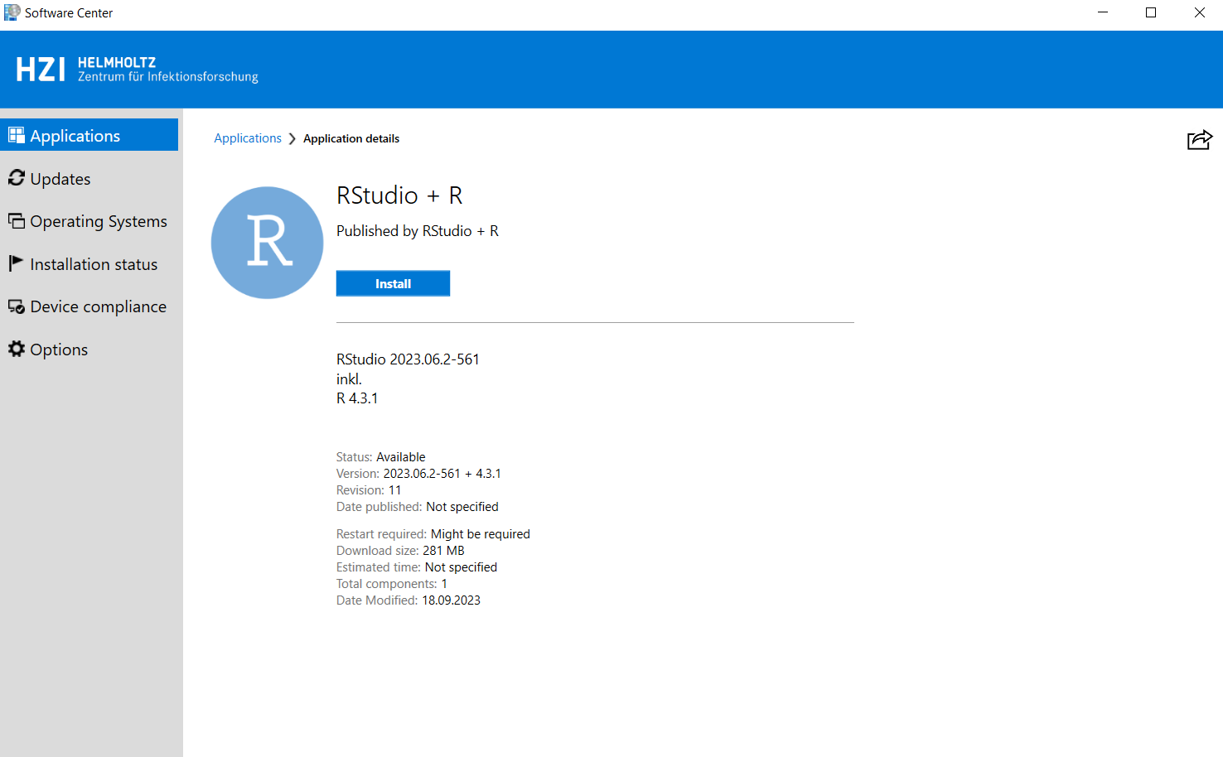Click the blue “Install” button.

## If you are not HZI-Member or using you own PC (you need administrator rights to install software on your machine):

1. Download “[R](https://cran.r-project.org/)” and “[RStudio](https://www.heise.de/download/product/rstudio)” either via the given links or on your own.
2. Go to your download folder and execute “R-4.3.2-win” by double clicking on it.

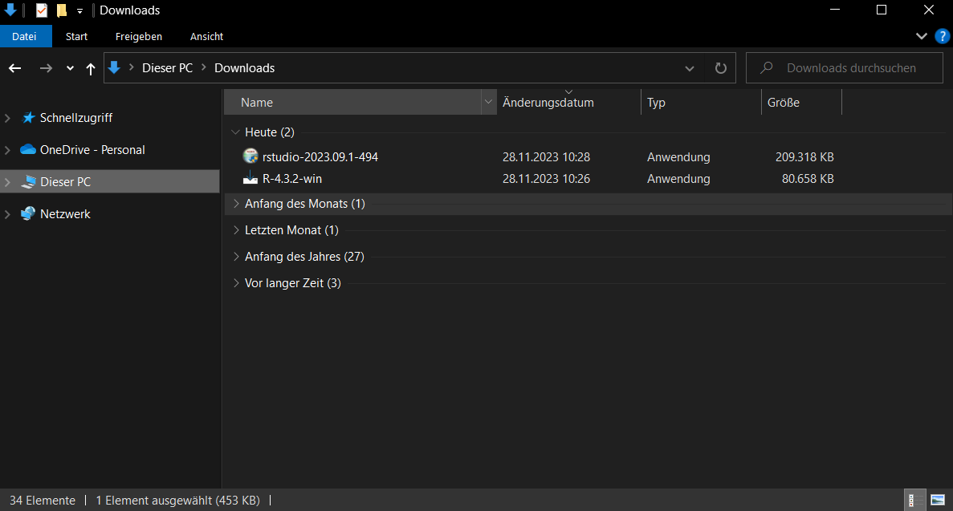

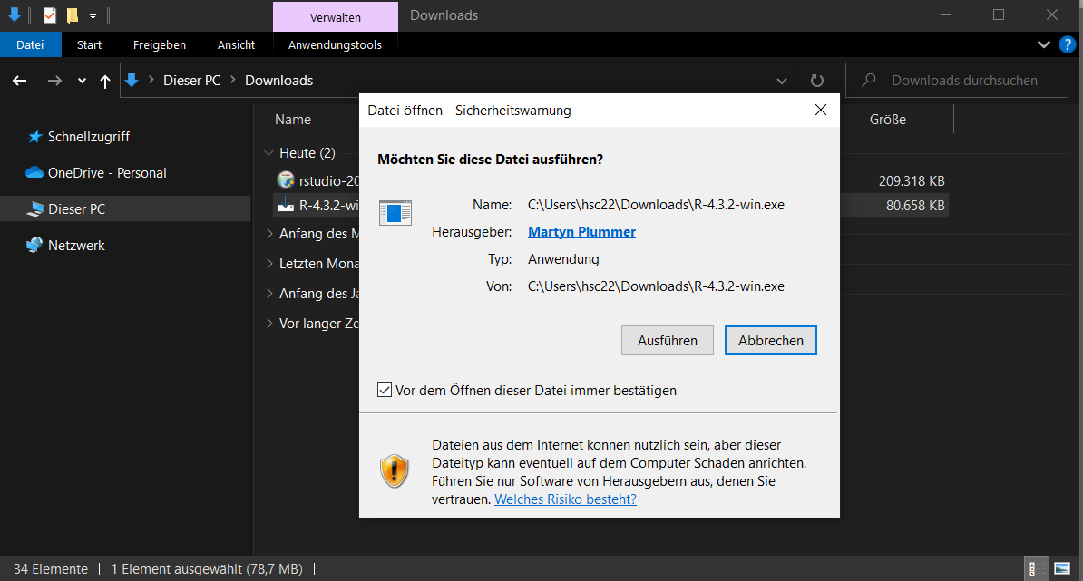

1. Choose a desired language and agree to the license. Follow the recommendations or change things as you wish.

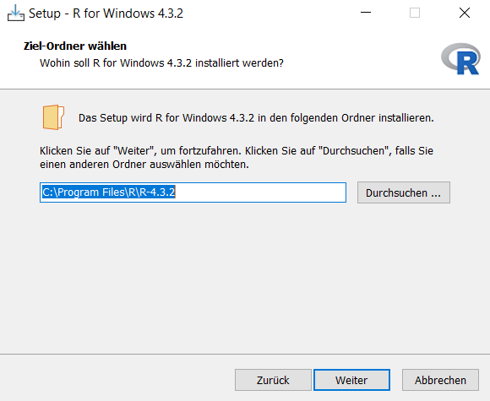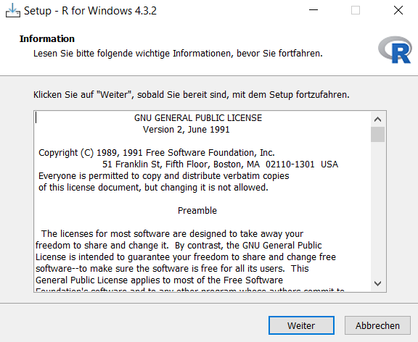

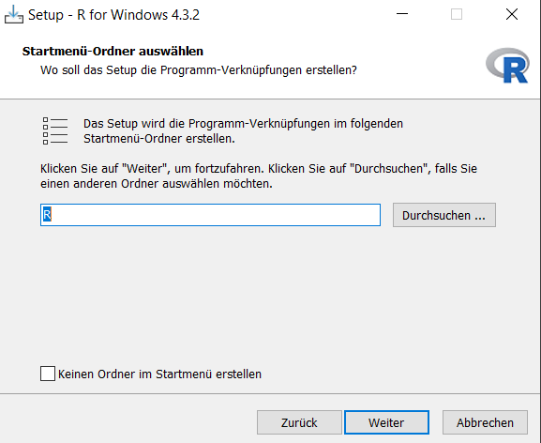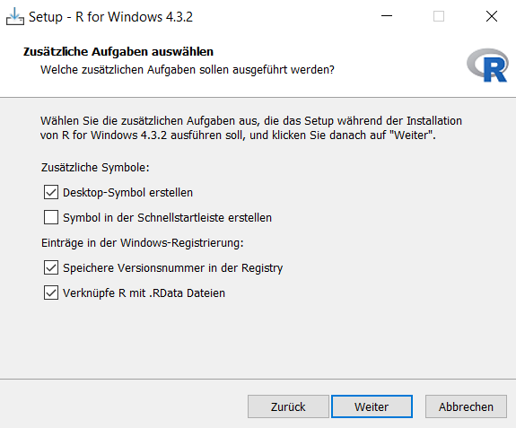

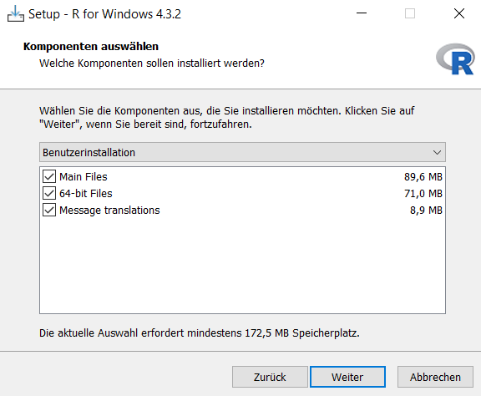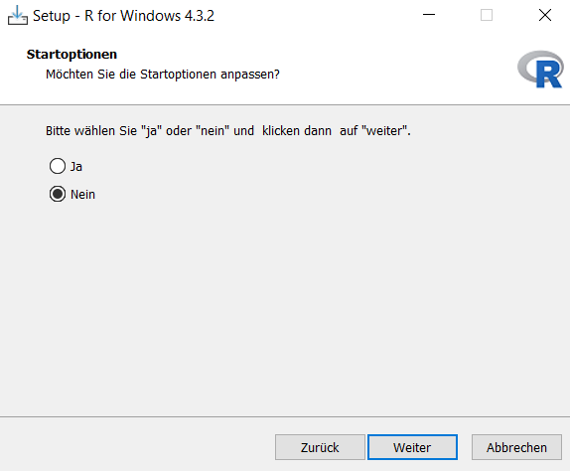

1. Wait until the installation is finished and finish the setup.

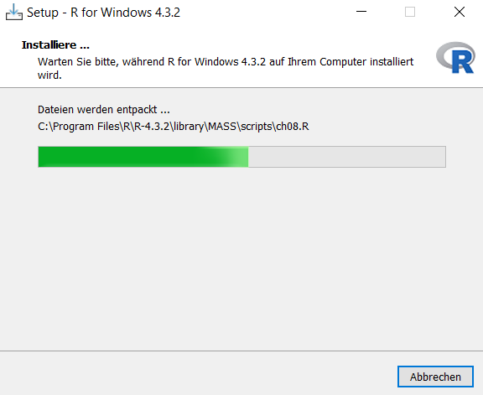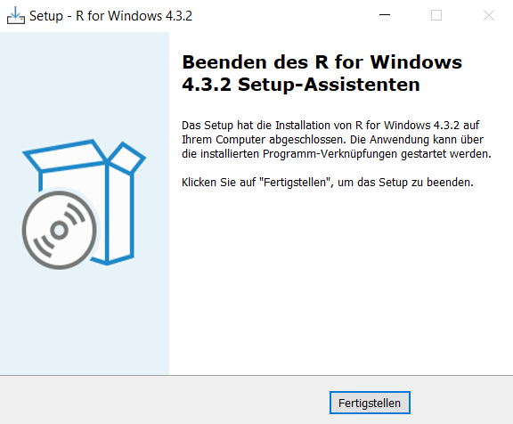

1. Execute the downloaded RStudio setup file and follow the recommendations until the installation is finished.

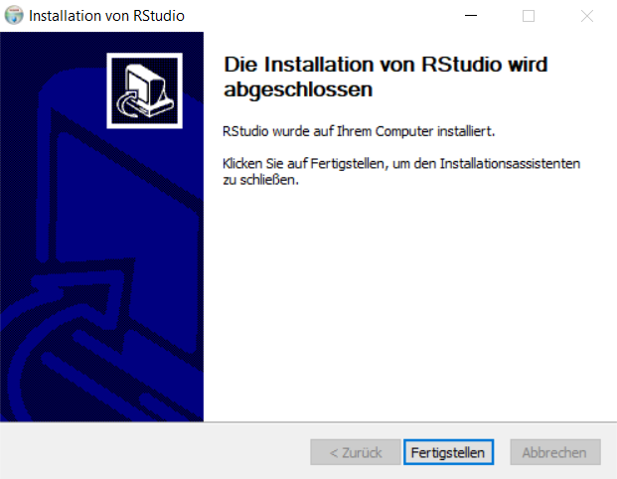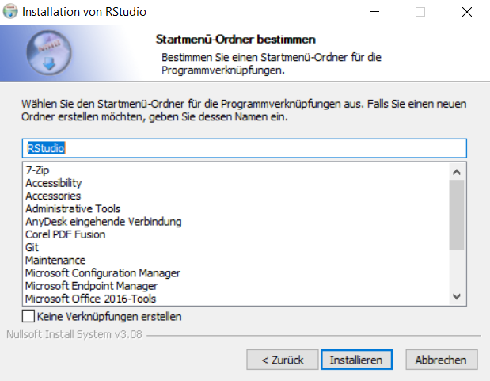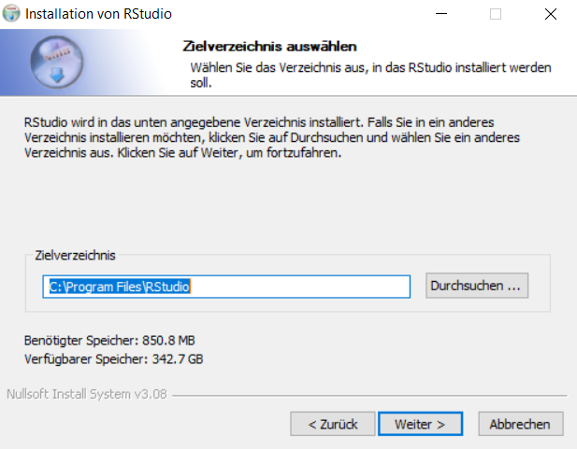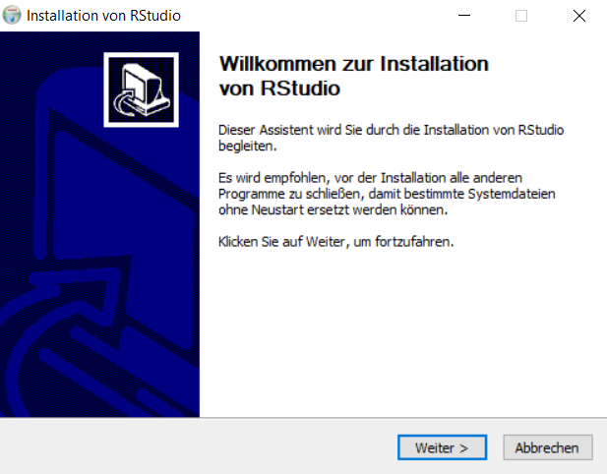

## Setting “RStudio” up and checking if the installation worked:

1. Start “RStudio”.

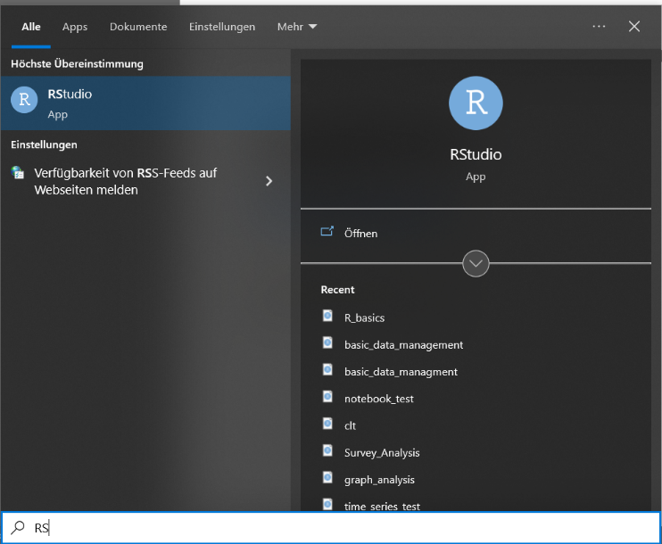

1. “RStudio” might ask you which version of “R” you want to use in “RStudio”. If so, click the option as shown below.

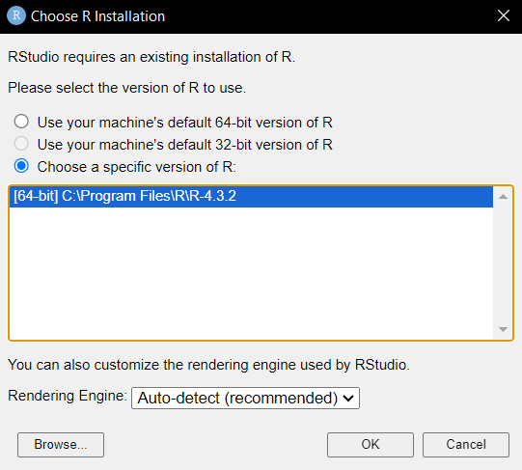

1. “RStudio” should start and look similar to the following image (some colors might be different). Click in the panel labeled “Console”. The cursor should flash right of “>”. Type “version” and hit Enter. The result should look similar to the image below.

